National University of Computer and Emerging Sciences, Lahore Campus

 | Course Name: | Introduction to Information and Communication Technologies | Course Code: | CL117
 | Program: | BS(CS,SE,DS) | Semester: | Fall 2020
 | Duration: | 180 Minutes | Total:
 | Paper Date: | 19 Feb, 2021 | Page(s):
 | Exam Type: | Final | Section: | ALL
Roll Number:________________________ Section:______________

Instructions:
- Attempt all questions
- You might use extra sheets for working but do not attach them.
- Write the final answer in the space provided for it.
- Calculators are not allowed.
- ASCII Chart is provided at the end.

Section | Marks | Marks  Obtained
MCQs | 15
Number System | 28
OS | 12
Mathematics | 16
AI and Data Science | 15
Database | 6
Computer Organization | 15
Web Development | 10
Networking | 5

Section: Multiple Choice Questions
1. What happens in the 'fetch' part of the Fetch Decode Execute Cycle?
- The RAM delivers the instruction.
- The processor fetches the instruction from primary memory.
- The program counter goes down by one.

2. Which of the following hardware components hold together crucial components of a computer like power connector, ROM chip and slots for graphic cards etc.
- CPU socket
- Motherboard
- RAM
- None of the above

3. Which of the following are the components of the CPU?
- ALU
- Control Unit
- Cache
- All of the above
- Both a&b

4. The __________________ moves the data between the registers , ALU and memory.
- Control Unit
- CPU
- Motherboard
- None of the above

5. A _____________ is a CPU register in the computer processor which has the address of the next instruction to be executed from memory.
- Program Counter
- Instruction Register
- Memory Buffer Register
- Memory Instruction Register
6. A graph is a collection of __________ connected with the help of _________.
- edges, vertices
- edges, nodes
- nodes, edges
- nodes , weights

7. Decide how much advertising to purchase in different media to minimize total cost while achieving a target level of reach or frequency. This can be regarded as __________ problem
- Optimization
- Prediction
- Regression
- Classification

8. Which of the following image techniques stores images in the form of pixels?
- Bitmap
- Vector graphics

9. Which of the following(s) is/are not an application of Computer Vision (choose one or more).
- Text to Speech Synthesis
- Aircraft Pilot Training Using Simulators
- Face Detection

10. What are the characteristics of a good database?
- Data integrity
- Avoiding Data redundancy
- Data Security
- All of the given above
. 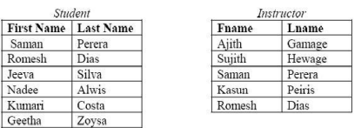
11. Consider the given tables Student and Instructor. Please note that Fname and Lname also denote the First Name and Last Name respectively. These tables are union compatible or not?
- Yes
- No

12. Which of the following SQL commands deletes a record of an employee with the employee_id 12345, from a table named PERSON.
- DELETE FROM person WHERE employee_id = ‘12345’
- DELETE WHERE person FROM employee_id = 12345
- DROP FROM person WHERE employee_id = 12345
- DELETE WHERE person WHERE employee_id = 12345
13. ML is a field of AI consisting of learning algorithms that?
- Improve their performance
- At executing some task
- Over time with experience
- All of the above
14. You’re running a company, and you want to develop learning algorithms to address each of two problems.
Problem 1: You have a large inventory of identical items. You want to predict how many of these items will sell over the next 3 months.
Problem 2: You’d like software to examine individual customer accounts, and for each account decide if it has been hacked/compromised.
Should you treat these as classification or as regression problems?
- Treat both as classification problems.
- Treat problem 1 as a classification problem, problem 2 as a regression problem.
- Treat problem 1 as a regression problem, problem 2 as a classification problem.
- Treat both as regression problems.
15. Of the following examples, which would you address using an unsupervised learning algorithm? (Check all that apply.)
- Given email labeled as spam/not spam, learn a spam filter.
- Given a set of news articles found on the web, group them into set of articles about the same story.
- Given a database of customer data, automatically discover market segments and group customers into different market segments.
- Given a dataset of patients diagnosed as either having diabetes or not, learn to classify new patients as having diabetes or not.

Section: Number System
1. How many different unsigned numbers can be represented using 16 bits? [1 point]
00
16 | 2^16 - 1 | 2^16 | 2^8

2. If the sign magnitude method is used to represent signed numbers, what is the range of numbers representable using 32 bits? [1 Point]

-2³²⁻¹-1 to 2³²⁻¹-1
M[X]
3. Encryption [8 Points]
An application saves passwords using following encryption algorithm:
i- Take a string s
ii- Write binary of the string s by converting each character to 7 bit binary of its ASCII values
iii- Flip the first two bits from right to left, 2 bits from left to right and the middle bit. For example if ASCII value of a character is 1001110, then after step 3 it will become 0100101
iv- Save the character against binary derived in step 3

Example:

Original Character | 7-bit ASCII Binary | After Step 3 | Encrypted Character
% | 01 0 0 1 01 | 10 0 1 1 10 | N

If the original password is &036. What is the encrypted 4-characters password?

Answer: M[X]

4. Fill out the following table. [6 points]

Decimal | Binary (8 bit) | Hexadecimal
45 | 00101101 | 2D
111 | 0110 1111 | 6F
251 | 11111011 | FB

5. Represent the following in 2’s complement. [8 Points]

Integer | 1 Byte representation | 2 Byte representation
-11 | 11110101 | 1111111111110101
11 | 00001011 | 0000000000001011
25 | 00011001 | 0000000000011001
-22 | 11101010 | 1111111111101010

6. Represent the following in Signed Magnitude. [4 Points]

Integer | 1 Byte representation
42 | 00101010
-42 | 10101010
29 | 00011101
-29 | 10011101

Section: Operating Systems
1. Identify each of the following if it is preemptive or nonpreemptive. [3 Points]
- Round Robin: preemptive
- First Come First Serve: nonpreemptive
- Shortest Job First : nonpreemptive
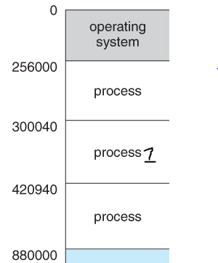
2. What are the values stored in the base register and bound register for the process1 according to the following memory map? [1+1 Points]

Base Register: _300040_

Bound Register: _120900_______

4. We have the following process states: new, running, waiting, ready, terminated.
Now suppose, we have a process p1. Write down the state name for each of the following scenarios for p1: [5 Points]
- Process p1 has just arrived: _NEW__
- Process p1 has arrived, but it cannot be executed right now by the CPU since the CPU is already executing another process: __READY
- Process p1 is currently being executed by the CPU: ____RUNNING___
- Process p1 needs to get data from the user via keyboard: __WAITING___
- Process p1 was being executed by the CPU, but due to an interrupt CPU is now allocated to another process. P1 is in __READY___ state now.

5. What is the average turnaround time for the following processes? Completion times of processes have been shown in the following gantt chart [2 Points]
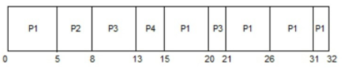
(32+8+21+15) / 4 = 19

Section: Mathematics in Computer Science
1. Represent the following graph in the form of an adjacency matrix. [5 Points]
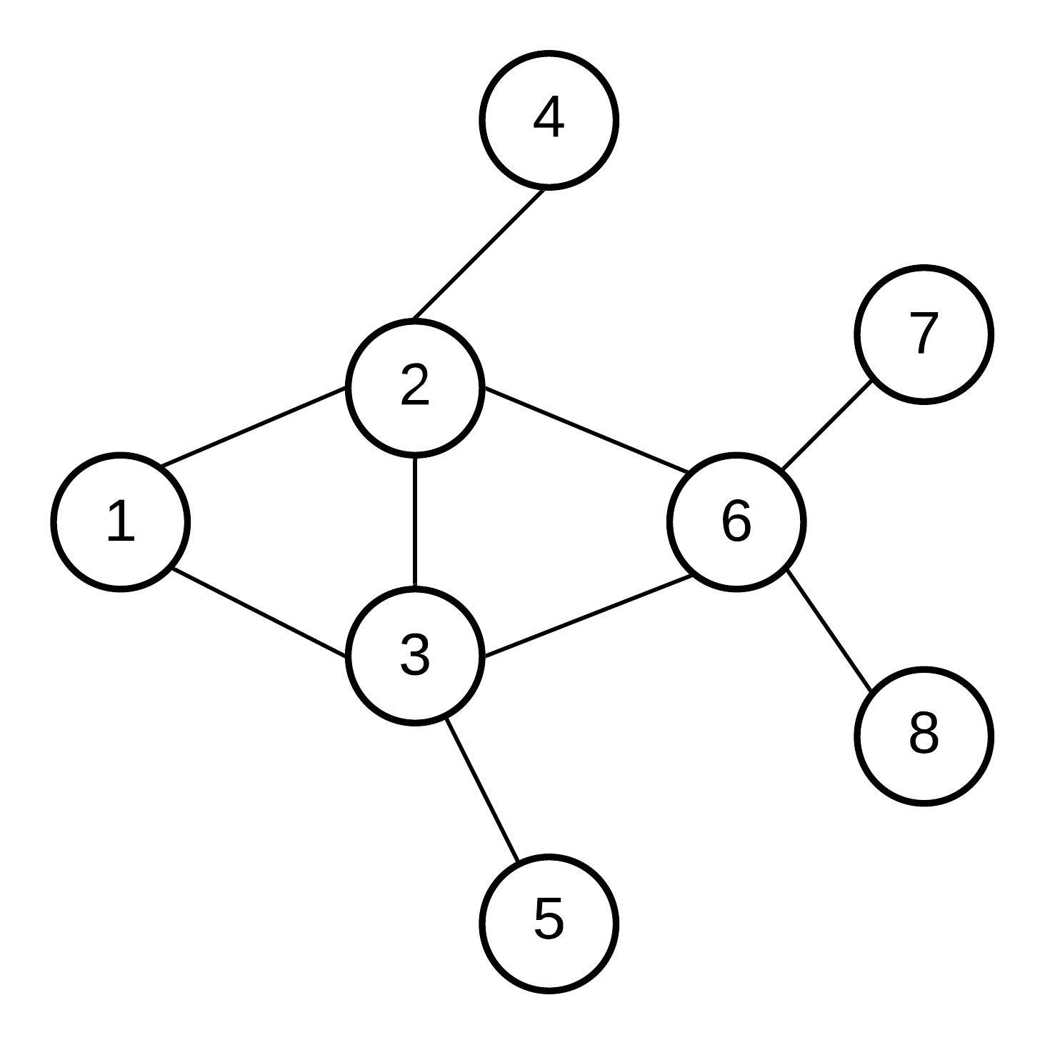
47kl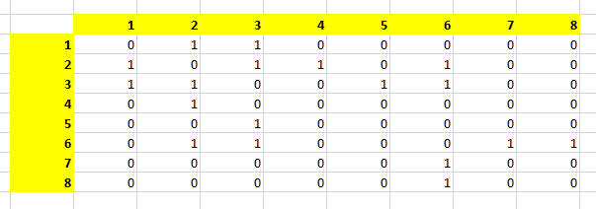

2. Given the following adjacency matrix, draw the corresponding graph. [5 Points]
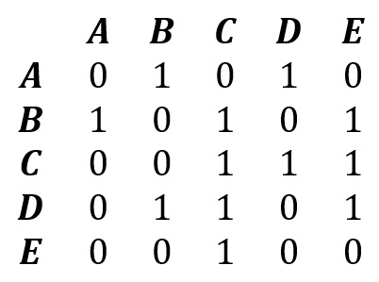
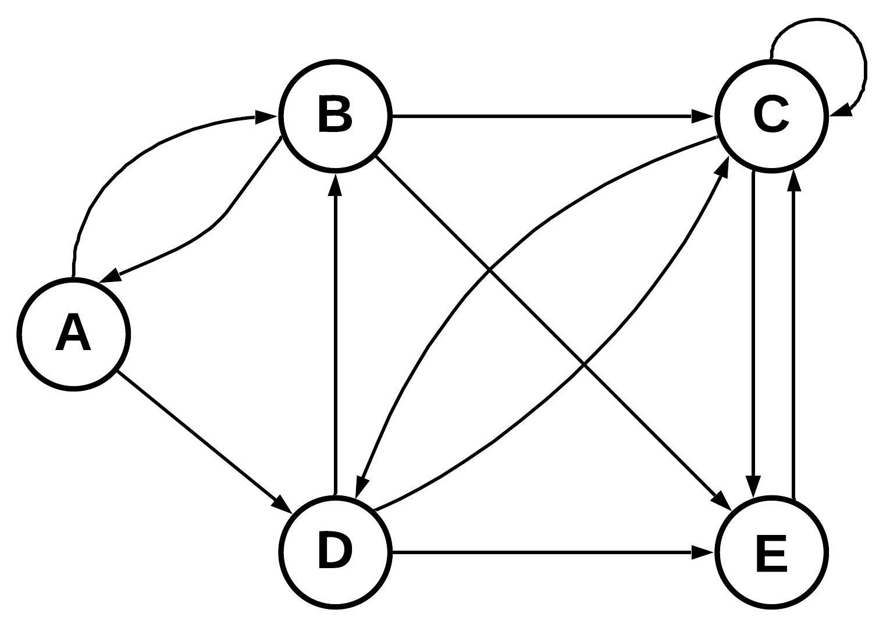

(This question 3 is for all sections except sections BCS-1H and BSE-1A)
3. (a) Given the graph below, find the shortest path from v1 to v6 using the method discussed in the class. Show all steps. [5+1 Points]
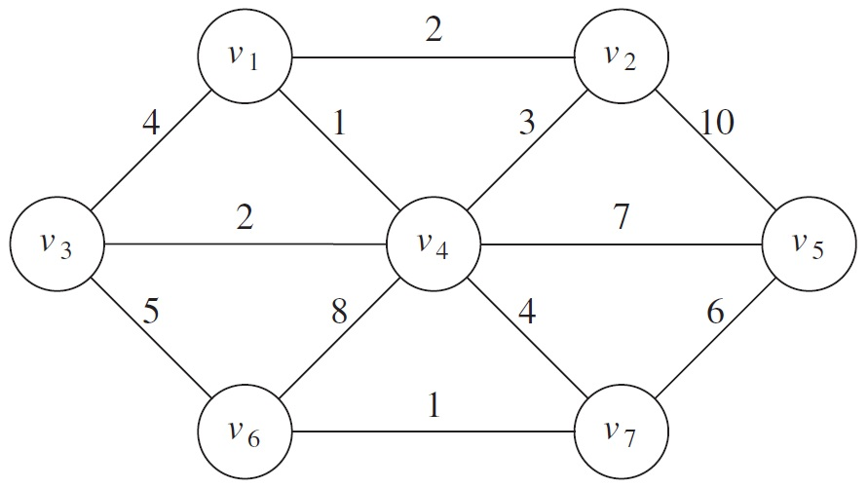

Step 1. Initialization
Unvisited = {v1, v2, v3, v4, v5, v6, v7}
 | v1 | v2 | v3 | v4 | v5 | v6 | v7
Distance | 0 (via v1) | ∞ | ∞ | ∞ | ∞ | ∞ | ∞
Step 2. Visiting v1
 | v1 | v2 | v3 | v4 | v5 | v6 | v7
Distance | 0 (from v1) | 2 (from v1) | 4 (from v1) | 1 (from v1) | ∞ | ∞ | ∞
Unvisited = {v2, v3, v4, v5, v6, v7}
Step 3. Visiting v4
 | v1 | v2 | v3 | v4 | v5 | v6 | v7
Distance | 0 (from v1) | 2 (from v1) | 3 (from v4) | 1 (from v1) | 8 (from v4) | 9 (from v4) | 5 (from v4)
Unvisited = {v2, v3, v5, v6, v7}
Step 4. Visiting v2
 | v1 | v2 | v3 | v4 | v5 | v6 | v7
Distance | 0 (from v1) | 2 (from v1) | 3 (from v4) | 1 (from v1) | 8 (from v4) | 9 (from v4) | 5 (from v4)
Unvisited = {v3, v5, v6, v7}
Step 5. Visiting v3
 | v1 | v2 | v3 | v4 | v5 | v6 | v7
Distance | 0 (from v1) | 2 (from v1) | 3 (from v4) | 1 (from v1) | 8 (from v4) | 8 (from v3) | 5 (from v4)
Unvisited = {v5, v6, v7}
Step 6. Visiting v7
 | v1 | v2 | v3 | v4 | v5 | v6 | v7
Distance | 0 (from v1) | 2 (from v1) | 3 (from v4) | 1 (from v1) | 8 (from v4) | 6 (from v7) | 5 (from v4)
Unvisited = {v5, v6}
Step 7. Visiting v6
 | v1 | v2 | v3 | v4 | v5 | v6 | v7
Distance | 0 (from v1) | 2 (from v1) | 3 (from v4) | 1 (from v1) | 8 (from v4) | 6 (from v7) | 5 (from v4)
Unvisited = {v5}
Step 7. Visiting v5
 | v1 | v2 | v3 | v4 | v5 | v6 | v7
Distance | 0 (from v1) | 2 (from v1) | 3 (from v4) | 1 (from v1) | 8 (from v4) | 6 (from v7) | 5 (from v4)
Unvisited = { }
Shortest Path: v1 -> v4 -> v7 -> v6

(b) Give the length of the shortest path.
6

(This question 4 is only for sections BCS-1H and BSE-1A)
4 (a) How can we represent people on facebook and their friends in the form of a graph. [6 Points]

A person on Facebook will be a node, and if he is friends with another person, then there will be an edge between the nodes of these two persons.

(b) Will it be a directed graph or undirected graph? Give an argument to justify your answer.
Undirected edge. Because both become friends unlike twitter or Instagram where if one person follows another person, then vise versa does not always hold true.
(c) Will it be a weighted graph or unweighted graph? Give an argument to justify your answer.
It will be an unweighted graph. Since an edge will mean that the two persons are friends. Such an edge does not need any weight.
(d) Explain in the form of pseudo code how you will give friend suggestions to a person on facebook. You can write pseudocode in English language.

Section: AI and Data Science
1. How Machine Learning has helped to predict COVID-19 diagnosis based on symptoms. Mention whether it would be supervised or unsupervised. [3 Points]
Supervised

2. Fill the Answer column with one of the following AI components. [3 Points]
a. Natural Language Processing b. Regression c. Unsupervised Learning
d. Robotics e. Classification f. Supervised Learning
Applications | Answer
Product Recommendations | c
Self-driving cars | d
Google assistant | a
Predicting House Prices | b
Face Recognition | f
Malignant vs Benign Cancer | e

5. Suppose you are developing a mobile application for your client. This mobile application will suggest songs based on facial expression. For example, if you are happy then it will show you the list of the songs accordingly. Is this a regression or classification problem? Support your answer with valid reason. [2 Points]
Answer:
This is clearly a classification problem. In classification, the output will be the class membership. So In this case our output would be either happy or unhappy.

Question 5:
stId | stName | prName | Cgpa
S1020 | Sohail Dar | MSCS | 2.8
S1038 | Shoaib Ali | BSCS | 2.78
S1015 | Tahira Ejaz | MSCS | 3.2
S1034 | Sadia Zia | BSDS | 3.3
S1018 | Arif Zia | BSDS | 3.0

1. (a) Write a query that gives you the complete data about students. [2 Points]

Answer:
select * from student

(b) Write a query that gives you the name of the students with the MSCS. [2 Points]
Answer:
select stName from student where prName=’MSCS’

.
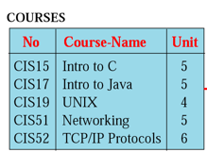.
2. What will be the effect of the query ( update COURSES set Unit = 6 ) on the table given above. [2 Points]

No | Course-Name | Unit
CIS15 | Intro to C | 6
CIS17 | Intro to Java | 6
CIS19 | UNIX | 6
CIS51 | Networking | 6
CIS52 | TCP/IP Protocols | 6

Question 6: [15 points]
1. Perform a fetch , decode and execute cycle on the following instructions, and fill the following tables according to each step of “Fetch Execute Cycle”. You have to update values in ALU, Control Unit, and Memory for Instruction 1. For your ease, the addresses are written in Binary. [5 points]
Instruction 1: SUB 200,300,400 (The values stored at memory location 400 is subtracted from the value stored at 300, and the result should be stored at 200)

2. What will be the value of the PC when instruction 1 will be Step 2. [1 points]
Answer: 150

Step1:Instruction Fetch
ALU | Control Unit  PC: 100  SUB 200,300,400

RAM
Address | Content
100 | SUB 200,300,400
150 | ADD 500, 200, 400
200 | 590
300 | 392
400 | 192
500 | 111
600 | 222

Step 2:Instruction Decode
ALU  [300]  [400]  [200] | Control Unit  PC:150  SUB 200,300,400

RAM
Address | Content
100 | SUB 200,300,400
150 | ADD 500, 200, 400
200 | 590
300 | 392
400 | 192
500 | 111
600 | 222

Step 3&4: Data Fetch and Instruction Execute
ALU  [300] 392  [400] 192  [200] 200 | Control Unit  PC:150

RAM
Address | Content
100 | SUB 200,300,400
150 | ADD 500, 200, 400
200 | 590
300 | 392
400 | 192
500 | 111
600 | 222

Step 5:Return Result
ALU  [300] 392  [400] 192  [200] 200 | Control Unit

Address | Content
100 | SUB 200,300,400
150 | ADD 500, 200, 400
200 | 200
300 | 392
400 | 192
500 | 111
600 | 222

Question 07: [10 points]

1. Write the output of the following HTML script.

<!DOCTYPE html>
<html>
<head>
<meta charset="utf-8">
<title>Black Goose Bistro</title>
</head>
<body>
<img src="flower.png" alt="Black Goose logo">
<h1>Black Goose Bistro</h1>
<h2>The Restaurant</h2>
<p>The Black Goose Bistro offers casual lunch and
dinner fare in a hip atmosphere. The menu changes
regularly.
</p>
<h2> Catering </h2>
<p> You have fun... we'll handle the cooking </p>
<h3> Location </h3>
Seekonk, Massachusetts. </br> Monday through Thursday, 11:00 to 21:00. </br> Friday and Saturday 11:00 to Midnight.
</body>
</html>

Answer:

[image]
Black Goose Bistro

The Restaurant
The Black Goose Bistro offers casual lunch and dinner fare in a hip atmosphere. The menu changes regularly.

Catering
You have fun... we'll handle the cooking

Location
Seekonk, Massachusetts.
Monday through Thursday, 11:00 to 21:00.
Friday and Saturday 11:00 to Midnight.

Question 08: [5 marks]

Q1: Which of the following topologies provides faster communication: Mesh Topology or Ring Topology? Give an argument to justify your answer. [2 marks]

Answer: mesh topology will provide faster communication because each computer is directly connected to all other computers in the network.

Q2: Which of the following devices can cause privacy issues? Switch, Hub, or Router. Given an argument to justify your answer. [2 marks]
Answer: hub, because it forwards the data to all connected devices.

Q3: Suppose we want to connect two networks together. If both networks are using different topologies, then what should we choose (bridge or gateway) to connect the two networks together. [1 mark]

Answer: gateway

